TC-PM-015
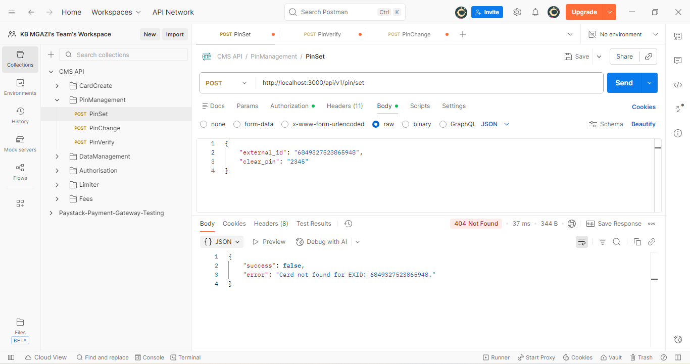
Request:
{
"external_id": "6849327523865948",
"clear_pin": "2345"
}
Response:
{
"success": false,
"error": "Card not found for EXID: 6849327523865948."
}

